

Database Project
Supervised By: Sir Kashif Khan


Made By:
Usama Noman (k11-2219)
M.Rafay Farooq (k11-2257)
Ramsha Khan (k11-2081)
Section A

Table of Contents
Mini-World: 4
Description: 4
Requirement Collection and Analysis 4
Functional Analysis: 5
Data Flow Diagram: 6
Data Analysis and Requirements: 10
Entity Relationship Diagram: 11

This page is left Blank Intentionally

Mini-World:
Online Freelancing Website

Description:
Our main aim behind building this project is to make a freelance website where interested users can make their account and find jobs as well as can post their projects to find human resource for the desire job. The main task behind building this project is not only to facilitate the freelancers, but also the companies who want freelancers time by time for their working projects. The website will provide a platform for the companies and other individuals to outsource their work and find the right person at the right time.

Requirement Collection and Analysis
Our system will facilitate the user to either sign-up as a Freelancer or as an Individual/Company who wants freelancers. The main focus behind providing these options at the time of sing-up is to maintain certain privileges among different level users at different time.
A user who sing-up as a freelancer cannot post projects. The only privilege he will have is to see the already posted projects and bid on them. The freelancer can maintain his profile so that at the time of bidding, the company or individual who is looking to hire him can see the complete details and decide whether he is compatible for the project or not.
Like-wise, the user who sing-up as an individual/Company can make projects and allow users to bid on the project. He can restrict the users by imposing some conditions or barrier on the level of experience or bid freelancer can make.
The freelancers are asked to update and add their skills and interest based on which they can divert more clients to their way. The site will notify the freelancers through email about the new projects posted on the web based on his interest and skills matches from his profile. One freelancer can bid on one project only single time, and after posting the bid he/she can’t update its details.
In addition, the freelancer can search the project on the basis of his skills, budget range, country and type. He can also add the details of projects he had done previously and provide back-links re-directing to that work. Like-wise, after completion of every project, it is must for the company individual to provide a feed back on the work provided by that freelancer and which is visible to his profile and can’t be hide. So that next time, if any other client wants to hire that freelancer then he can first see the feedbacks of other and the make a final decision.
The administrator plays the third man role in the system. He will have the privilege to either approve or disapprove the projects posted by the Clients. He act as a moderator and make sure that no user involves in spamming and use any abusive language in his project details or profile etc which destroy the decorum of the site.
The system will charge a percentage amount from each deal project owners and workers make. The freelancer will be able to get paid after reaching the threshold (minimum) amount and owners will have to deposit a certain advance amount to the website before he ask a worker to work for him.
The task of making this project is to launch a complete product, which will facilitate the person who wants to earn from home and to outsource their projects for a low cost or quality.

Functional Analysis:
Our functional requirements have been distributed on three major roles namely Client, Admin and Freelancer.
Functional Features of Clients
- Client can sign-up
- He can then log-in to the system after email verification.
- Make projects and add certain mandatory details on it.
- Visit already posted projects.
- Check the bids on his already posted projects.
- Update his Company Profile.
Functional Features of Freelancer

- Freelancer can login after signing up and verification of email.
- Freelancer can update his profiles, maintain his online CV.
- Freelancer can search for projects by category and title.
- Freelancer can see complete details of already posted projects
- Freelancer can make a bid on projects.

Functional Features of Administrator
- Admin can see the profiles of Freelancers and have the authority to remove them.
- Admin can see Company Profiles and also have the privilege to remove them in case they are found fake.
- Admin can also see the project details being posted.
- Admin can also see all the bids on the project and have the authority to delete them.

Functional Analysis and design can be easily illustrated to the flow of data in our system. For this purpose, we will have the Data Flow diagram which is a software design technique to describe and illustrate the functional analysis and requirement.

Data Flow Diagram:
The first diagram called Context Level describes the upper level details of data flow on the system. In our scenario, the main process is our system and three external entities Freelancer, Administrator and Client are interacting with it having different behaviors and methods. All the external entities are giving some input to the system (process) and receiving net output.
Context Level:

Data Analysis and Requirements:
Following are the data requirements require for the functionality of Features explained in Functional Analysis.
Freelancer:
Following are the data requires for Freelancer:
- Registration ID, First Name, Last Name, Email, Password, Country, Address, Payment Information (Verification), House Number, Zip.
Client:
Following are the data requires for Client:
- Registration ID, First Name, Last Name, Email, Password, Country, Address, Payment Information (Verification), House Number, Zip.
In addition with that, the Client has to maintain the additional information about his company like
- Company About, Number of Employees, Name of Company.
Project:
Project will have the following details:
- Project id, Name, Details, Skills Require, Type, Category, Estimated amount per hour, Bids.
Freelancer Bids:
Bid will have the following data details:
- Bid-id, Data and Time, Claim, Purpose Amount, Status, Skills, Links to Previous Work.

By merging the functional requirements with data analysis, we will have our logical schema. On the following notes, we will discuss the logical design of our database and the relation they have with each other. On the basis of that logical design, we will have our physical design.

Entity Relationship Diagram:
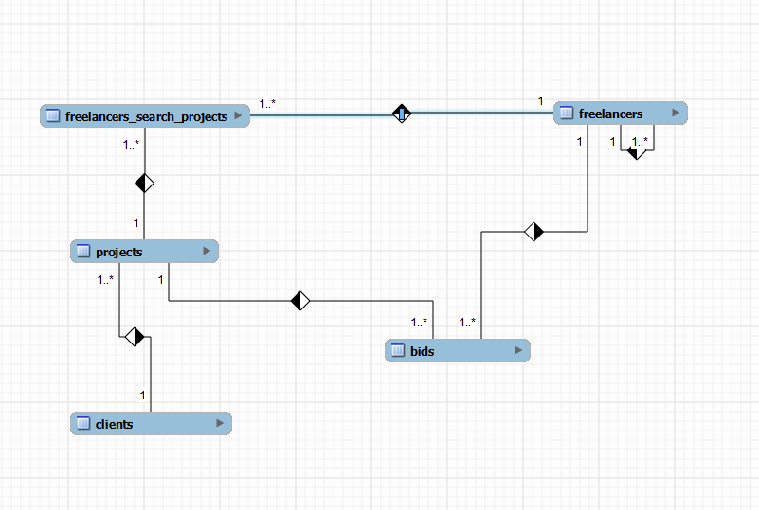
This ERD diagram shows the relation between our four tables called
- Freelancers
- Projects
- Clients
- Bids
The fifth table is the result of MANY-MANY relationship and formed between Freelancer and Project. In addition, a self relationship is formed in freelancer which indicates the role of Admin, since both have similar properties we do not need to create a separate table for them.

